Project Report

On

HIGHWAY WIND TURBINE

Submitted in partial fulfillment of the requirements

For the award of the degree

Of

BACHELOR OF TECHNOLOGY

In

Mechanical Engineering



Under the guidance of: Submitted by:

DR. O.S. Prajapati Aman kumar (15/018)

(Assistant professor) RajKumar Gupta (15/330)

Hariom Nagar(15/126)

Balkishan(15/069)

DEPARTMENT OF MECHANICAL ENGINEERING

RAJASTHAN TECHNICAL UNIVERSITY, KOTA

May,2019

**CERTIFICATE**

This is to certify that the project entitled “HIGHWAY WIND TURBINE” submitted by Group of four student named Aman kumar ,Raj Kumar Gupta, Balkishan, Hariom in partial fulfilment of the requirements for the award of Bachelors of Technology in (Mechanical/ Production and Industrial/ Aeronautical) Engineering at the University Departments, Rajasthan Technical University, Kota is an authentic work carried out by them under my supervision and guidance. To the best of my knowledge, the matter embodied in the project has not been submitted to any other University/Institute for the award of any Degree or Diploma.

The report has been prepared as per the prescribed format and is approved for submission.

Dr. O.S. Prajapati

(Assistant professor)

Department of Mechanical Engineering

Rajasthan Technical University

**i**

**DECLARATION**

I hereby declare that the work reported in B. TECH Final year project report entitled on“HIGHWAY WIND TURBINE” Submitted at “**UNIVERSITY DEPARTMENT RAJASTHAN TRCHNICAL UNIVERSITY KOTA** ” is an authentic record of my own work carried out under the guidance of **Dr. O.S.PRAJAPATI (Assistant prof. UD,RTU,KOTA)**. I have not submitted this work elsewhere for any other degree or diploma. I am fully responsible for the content of my B.TECH seminar report.

**ii**

**ACKNOWLEDGEMENT**

We take this opportunity to thank the Final year project Co-Ordinator of Mechanical Engineering Department for allowing us to work on such an interesting & informative topic. We are highly indebted to our project guide Asst. Professor Dr O.S. Prajapati Sir for his guidance & words of wisdom. He always showed us the right direction during the course of this project work. We are duly thankful to him to referring us to sites like science direct, opened & providing many research papers which had some research work.

We worked as a team and saw ups and downs which are part of any project work. But in the end it was their Guidance and my team work which made this project possible. Last but not the least we would also like to thank all our teachers & friends for their constructive criticism given in right spirit.

Aman kumar (15/018)

Raj Kumar Gupta (15/330)

Balkishan(15/069)

Hariom Nagar(15/126)

8th Semester, B.TECH. Department of Mechanical Engineering

Rajasthan technical university, kota

**iii**

**ABSTRACT**

This project (Design of Aero leaf Wind Turbine) is about designing and manufacturing a Vertical Axis Wind Turbines VAWT to transfer the wind speed to a rotational motion using these turbines. These turbines will be attached to a manufactured tree that will look like a modern design, which can be installed in and around any public area such as parks, roads, public facilities, or business offices. Aero leaf Wind Turbines are designed to produce power up to 300 watts for each turbine.

This project presents a review on the performance of Savonius wind turbines. This type of turbine is not commonly use and its applications for obtaining useful energy from air stream is still considered as an alternative source. Low wind speed start-up, working with any wind direction, and the less noise are some advantage of VAWT- Savonius model.

This project consists of three phases; designing, fabrication, and evaluating. An actual of gained power is reported to be 31~35% relative to the theoretical gained power due to the instability and inefficient of the wind speed.

**iv**

List of figure

|  |  |  |
| --- | --- | --- |
| **Figure No.** | **Description** | **Page No.** |
| 1.1 | GLOBAL TREND IN WIND ENERGY, DATA FROM THE GLOBAL WIND ENERGY COUNCIL. | 3 |
| 2.1 | HAWT OVERVIEW LAYOUT | 6 |
| 2.2 | VAWT OVERVIEW LAYOUT | 7 |
| 2.3 | BLADE DYNAMIC TORQUE COEFFICIENT FOR DIFFERENT ARC ANGLE | 9 |
| 2.4 | COMPUTER SIMULATION OF HIGHWAY WIND TURBINE, INDIA | 10 |
| 2.5 | CAD MODEL OF HIGHWAY WIND TURBINE | 11 |
| 2.6 | HIGHWAY WIND TURBINE TESTING | 11 |
| 2.7 | MARK OBERHOLZER, GUARDRAIL WIND TURBINE DESIGN | 12 |
| 2.8 | HONG KONG UNIVERSITY AND LUCIEN GAMBAROTA OF MOTORWAVE LTD. | 13 |
| 2.9 | ARIZONA STATE UNIVERSITY STUDENT DESIGN | 13 |
| 2.10 | ARIZONA STATE UNIVERSITY STUDENT REALISTIC DESIGN | 14 |
| 3.1 | APPLIED PHASES OF USED METHEDOLOGY | 16 |
| 3.2 | LABELED PARTS OF A VERTICAL WIND TURBINE | 18 |
| 3.3 | CAD MODEL OF HIGHWAY WIND TURBINE | 18 |
| 3.4 | BLADE DESIGN OF HIGHWAY WIND TURBINE | 20 |
| 3.5 | DRILLED CENTRE SHAFFT | 20 |
| 3.6 | GENERATOR | 21 |
| 3.7 | BEARING OF HIGH WAY WIND TURBINE | 21 |
| 5.1 | AVERAGE WIND SPEED READING IN INDIA | 30 |

List of table

|  |  |  |
| --- | --- | --- |
| **Table No.** | **Description** | **Page No.** |
| 2.1 | MAXIMUM COEFFICIENT OF POWER FOR DIFFERENT CASES | 9 |
| 4.1 | THEORITICAL GAINED POWER CALCULATION | 24 |
| 4.2 | EXPERIMENAL READING | 25 |
| 5.1 | COST OF THE PROJECT | 27 |

**v**

**LIST OF CONTENT**

CHAPTER 1. INTRODUCTION 1-4

* 1. About
  2. Current Scenario
  3. Importance
  4. Objective Of The Project
  5. Constraints and requirements
  6. Global Application
  7. Application

CHAPTER 2. LITERATURE SURVEY 5-14

* 1. Project Background
  2. Previous work
  3. VWAT on highway
  4. Conceptual Design

CHAPTER 3. SYSTEM DESIGN 15-22

3.1 Requirement Constraint Specification

3.2 Design Methodology

3.3 Proposed Design

3.4 Major component

3.5 Methodology

CHAPTER 4. SYSTEM TESTING AND ANALYSIS 23-25

4.1 Theoretical wind turbine power calculation

4.2 Experimental Readings

4.3 Result

CHAPTER 5.PROJECT ANALYSIS 26-33

5.1 Project management

5.2 Life-long learning

5.3 Impact of engineering solution

**vi**

5.4 Contemporary issue addressed

5.5 Advantages

5.6 Disadvantages

5.7 Applications

CHAPTER 6. CONCLUSION 34-35

REFERENCES 36-37

**vii**

**CHAPTER 1**

**INTRODUCTION**

**1.1 About**

This project mainly focuses on generating a electrical energy from Wind Energy. The idea proposed here is a new technique to generate electrical energy From Wind Energy produced due to the vehicle motion in Highways. Using a Turbine mechanism which is easy to implement. Cost effective without disturbing the current Road Design or even disturbing the traffic.

Wind power is extracted from air flow using wind turbines or sails to produce mechanical or electrical power. Windmills are used for their mechanical power, wind pumps for water pumping, and sails to propel ships. Wind energy as an alternative to fossil fuels, is plentiful, renewable, widely distributed, clean, produces no greenhouse gas emissions during operation and uses little land. The effects on the environment are generally less problematic than those from other power sources.

Recently, in order to comply with the policies of energy conservation and use of renewable sources of energy the power is generated by wind energy and other renewable energy sources.

**1.2 Current Scenario**

As of 31 March 2014, total installed capacity in India is 255.012 GW. Most of the energy requirement is served by the conventional sources, a major part of which is contributed by thermal power plants. In India almost 177.742 GW of energy is generated by thermal plants, 40.799 through hydroelectric power plants, 4.78 GW through Nuclear power plants and remaining 31.692 GW through other renewable source. India’s electricity sector is amongst the world’s most active players in renewable energy utilization. India stands 5th in wind power generation with an installed capacity of 21.136 GW. Even though, we are facing a deficit of electrical energy due to lack of resources as well as the increased power demand. Currently, we are trying to incorporate more renewable sources into the grid to support the increased power

1

demand. As a part of it a lot of researches are going on in the field of wind power generation

and the researchers are trying to exploit the field of highway wind power generation as highway is one of the potential source of wind energy.

**1.3 Significance/Importance of the Project**

Since we are depending mostly on non-renewable sources, and they are depleting in a very fast manner, currently there is a shortage of electric power in the world. Also, pollution due to conventional sources like coal, diesel etc. is also a major problem. Because of these above mentioned reasons, we are trying for incorporation of more renewable energy resources (like solar, wind etc.) into the grid to support the increasing power demand. These renewable sources are long term sources of energy and only capital cost is significant for its implementation. Nowadays, the vehicle density is increasing by a very fast rate and because of the development in road transportation facilities such as the development of express highways and national highways, where vehicles move in immense speed, large amount of wind energy will be generated by the moving vehicles on these highways.

**1.4 Objective Of The Project**

The main objective of this project is gaining power from wind. Therefore, this project is green

source of energy and has no effect on the life of earth. These wind energy turbines are small and can produce up to 300 watts for each turbine.

Another objective of this project is gaining and exercising some engineering concepts such as:

• Incorporation of more renewable energy to the power system.

• Design of a new method of generation of electricity using the wind energy generated by the moving vehicles on the highways.

• Development Stand-alone system for providing the power to the highways.

**1.5 Constraints and requirements**

One of the most difficultly problem is the lack of necessary equipment needed for the analysis and selection of materials accurately in the university. Also, in the market, I was really difficult to find some of the needed materials.

These problems make the function of this project relying for some parts in design of previous

2

studies mentioned in chapter 2 by doing the reverse engineering. Getting a sufficient wind, to analyze and test work. It was also the one of the berries that we have encountered, because of the lack of wind in the area at that time, and the lack of experience in aerodynamic science.

Beside the Lack of important resources, the lack of financial support was a major obstacle in our way even though the budget was estimated.

Although the existence of moral support from our professors, Lack of sufficient time was a real challenge to show up the work as long as there was only one semester to complete the senior project.

**1.6 Global Application**

The design can be used in any city around the world. It should be environmentally friendly. Labels in various languages and manuals will be provided for each specific city. Figure 1.1 shows a dramatic increase in the employment of wind energy globally. Wind power increased by nearly 20% in 2012 reaching a new peak of 282 GW. such as the Global Wind Energy Council show China as the leading country in the employment of Wind energy. 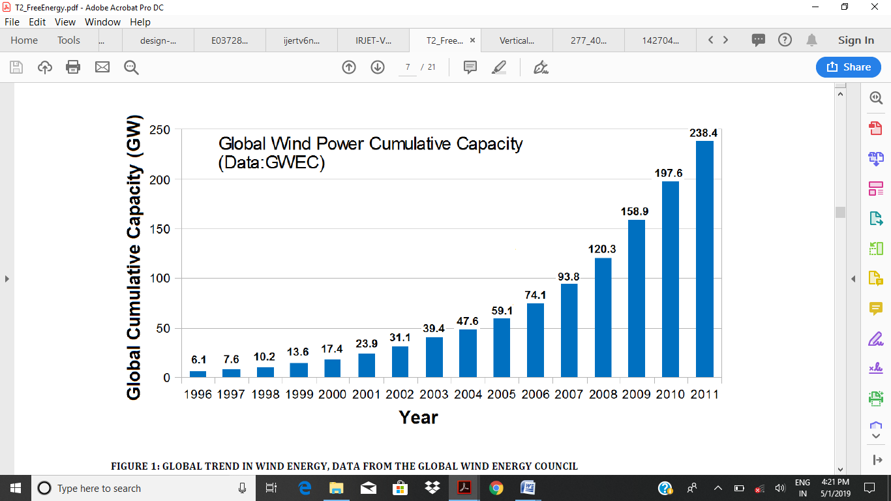 FIGURE 1.1: GLOBAL TREND IN WIND ENERGY, DATA FROM THE GLOBAL WIND ENERGY COUNCIL.

3

PROBLEM STATEMENT

A major hindrance in the growth of wind energy is fluctuation in the sources of wind. Highways appear to be a sufficient source of potential wind energy. An in-depth analysis of fluid flow due to traffic on highways must be performed to acquire boundary limits for the wind turbine design. The turbine must be able to store energy for use when there is low traffic, bumper to bumper or stop and go traffic. The design must be sustainable and environmentally friendly.

**1.7 Application**

This project idea is very simple, where it focuses on utilizing the wind energy by designing

and manufacturing vertical wind turbine and install this on highway. And utilize the wind through running vehicle and convert the wind energy into electricity through vertical wind turbine.

4

**CHAPTER 2**

**LITERATURE SURVEY**

**2.1 Project Background**

Energy is the main economy base of any country. Sources of energy are not easy to have. Having multiple sources of energy is extremely important to secure the basic living requirement of any country. Utilizing the nature could help in converting some of the natural phenomenon such as sun, wind, sea and oil into useful energy. This kind of energy called renewable energy.

Science Daily Research Newspaper has defend renewable energy as “The most common definition is that renewable energy is from an energy resource that is replaced rapidly by a natural process such as power generated from the sun or from the wind.

Recently, the increasing demand of renewable energy is very well noticed. According to a report by the International Energy Agency, the increase of amount of electricity produced from renewable sources increased from just over 13% in 2012 to 22% the following year. They also predict that that figure should hit 26% by 2020.

The traditional power plants in Saudi Arabia are mainly working on the fuel either gas or oil which are not environmental friendly. Eco Spark environmental charity has considered oil power plants as one of the most contributors of environment pollution. Eco Spark environmental charity has listed the below most significant environmental impacts:

* Oil causes air pollution and greenhouse gas emissions.
* Oil uses large amounts of water, and creates water pollution and thermal discharge.
* Oil creates hazardous sludge and solid waste.
* Extracting and refining oil is environmentally destructive.
* Transporting oil is risky and can harm the environment.
* Oil is a non-renewable electricity source.

Such of the above environment affects lead us to think seriously about the renewable energy sources, which will eliminate the environment hazard and improve health and life style. Wind

5

energy is one of the most important energy sources. The concept of wind energy is transforming the winds kinetic energy into mechanical energy. This energy drive blades that turn generators that produce electricity. Our project is fitting with wind energy source. The idea of this project is to convert the wind by using Vertical Axis Wind Turbines (VAWT) into power.

They are two types of wind turbines, Horizontal Axis Wind Turbines (HAWT) as shown in

figure 2.1 that is more commonly used across the world and they are used as a power plants.



Figure 2.1 HAWT overview layout

These kind of turbines are the most efficient of wind turbine. Cole Gustafson from Dakota State University has mentioned the advantages and disadvantages of horizontal axis vs vertical axis wind turbines, “In research studies evaluating wind turbine performance, horizontal axis machines have been shown to be more efficient than vertical axis machines. However, the blade span of horizontal wind turbines is larger than vertical axis machines which limits placement confined spaces. Some people also find the large blade area of horizontal axis machines objectionable”.

The other type of wind turbine is the Vertical Axis Wind Turbines (VAWT) as shown in figure 2.2. VAWT is the most popular of the turbines that people are using to make their home a source of renewable energy.

6



Figure 2.2: VAWT overview layout

VAWT is not as commonly used as the Horizontal Axis Wind Turbine. The reason behind that is that VAWT is less efficient than HAWT when considered as a power plant generator. However, for the small scales like homes, parks, or offices VAWT is more efficient. “Vertical axis turbines are powered by wind coming from all 360 degrees, and even some turbines are powered when the wind blows from top to bottom. Because of this versatility, vertical axis wind turbines are thought to be ideal for installations where wind conditions are not consistent, or due to public ordinances the turbine cannot be placed high enough to benefit from steady wind”.

**2.2 Previous work**

There are two different styles of vertical wind turbines. One is the Savonius model, which is our project is based on, and the other type is the Darrieus model. The first model looks like a gallon drum that is been cut in half with the halves placed onto a rotating shaft. The second model is smaller and looks much like an egg beater. Most of the wind turbines being used today are the Savonius models.

Renewable Energy UK website provided some information about these two model. “A Savonius is a type of vertical axis wind turbine (VAWT) generator invented in 1922 by Sigurd Johannes Savonius from Finland though similar wind turbine designs had been attempted in previous centuries.".

7

“A Darrieus is a type of vertical axis wind turbine (VAWT) generator. Unlike the Savonius wind turbine, the Darrieus is a lift-type VAWT. Rather than collecting the wind in cups dragging the turbine around, a Darrieus uses lift forces generated by the wind hitting aero foils to create rotation.

In Jun 2.15, International Research Journal of Engineering and Technology (IRJET) has published a research titled “DESIGN, ANALYSIS AND FABRICATION OF SAVONIUS VERTICAL AXIS WIND TURBINE.

This research discussion was to showcase the efficiency of Savonius model in varying wind conditions as compared to the traditional horizontal axis wind turbine. It evaluated some observation that showed that at low angles of attack the lift force also contributes to the overall torque generation. Thus, it can be concluded that the Savonius rotor is not a solely drag-driven machine but a combination of a drag-driven and lift-driven device. Therefore, it can go beyond the limit of Maximum power coefficient Cp established for the purely drag-driven machines. Some of this researched conclusions are that The vertical axis wind turbine is a small power generating unit with the help of free source of wind energy. It is designed under consideration of household use. Generally, At least 10% power of the consumption can be fulfil by the Savonius model.

The research has also resulted that this turbine is generally suitable for 8 to 10m of height above ground level. Because at ground level velocity of air is very less. And finally the alternate option for turbine blade material is reinforced glass fiber because of its more elastic nature but it is costlier than aluminum alloy.

To have the best efficiency of the power output from our turbine, the team has done some brainstorming in what are the most significant factor that affect the turbine, the blade angle was agreed to be the most significant one.

By doing some researches, we fined an article that focusing in the turbine blade angle. A research article published by Advances in Mechanical Engineering (AIME) with a title of “EFFECT OF THE BLADE ARC ANGLE ON THE PERFORMANCE OF A SEVONIUS WIND TURBINE*”.*

This article is focusing on how to improve the efficiency of the turbine by selecting the best blade angle.

8

The effect of the blade arc angle on the performance of a typical two-bladed Savonius wind turbine is investigated with a transient computational fluid dynamics method. Simulations were based on the Reynolds Averaged Navier–Stokes equations, and the renormalization group turbulent model was utilized.

The numerical method was validated with existing experimental data.

The results of this article indicate that the turbine with a blade arc angle of 160° generates the maximum power coefficient cp 0.2836, which is the highest that gain from the experiment.

The article provided the below table 2.1, which shows the maximum coefficient of power for different cases. Figure 2.3 shows the blade dynamic torque coefficient for different blade arc angles.

Table 2.1:Maximum coefficient of power for different cases

 

Figure 2.3 Blade dynamic torque coefficient for different blade arc angles

9

**2.3 VWAT on highway**

The idea to utilize wind turbines on the highway is not entirely unique. There have been attempts by several individuals and groups to recycle energy from highways. The most impressive is a design displayed on a YouTube video entitled “Highway Helical Wind Turbine Project (Next Generation Highway's Potential For Wind Power).” In the video a group of Mechanical Engineering Students from YCET Kollam, Kerala display a prototype of their highway wind turbine as seen in Figures 2.4.



FIGURE 2.4: COMPUTER SIMULATION OF HIGHWAY WIND TURBINE, INDIA

Figure 2.5: is still of a computer animated design of a highway wind turbine proposed by Mechanical Engineering student in india.

10

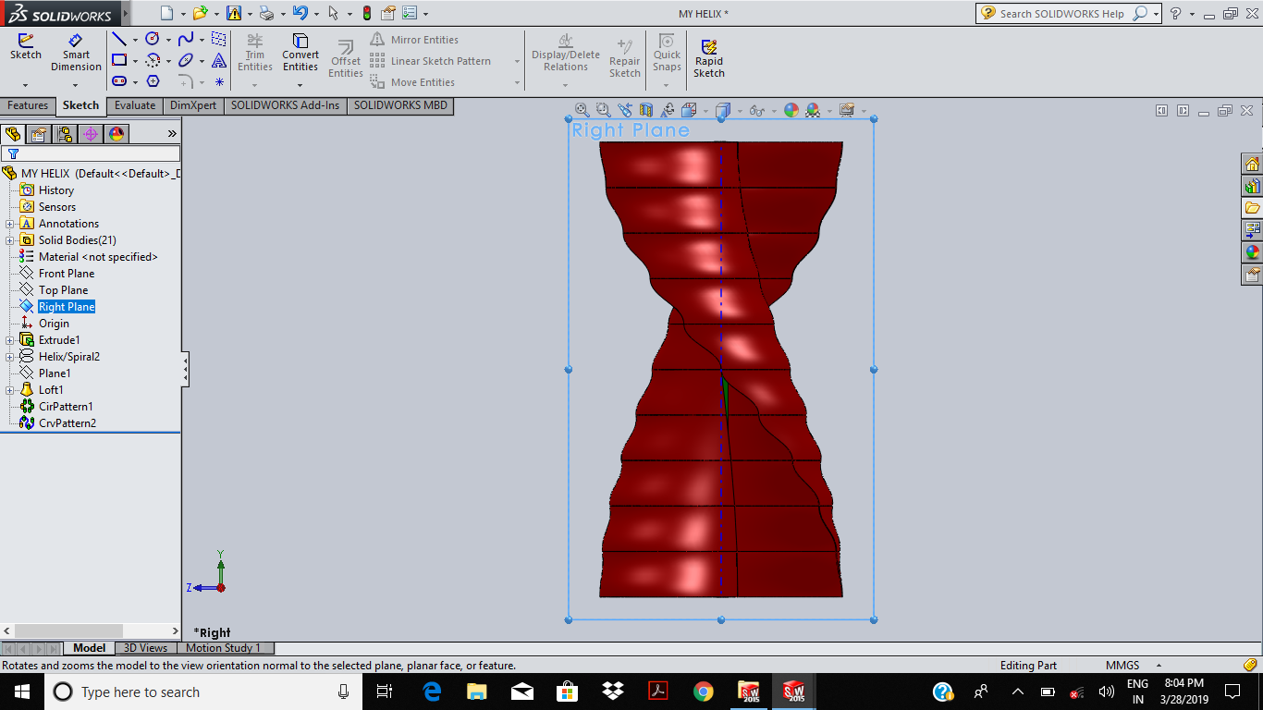

FIGURE 2.5: Cad model of highway wind turbine

In Figure 2.6: the students demonstrate a working prototype of their design.

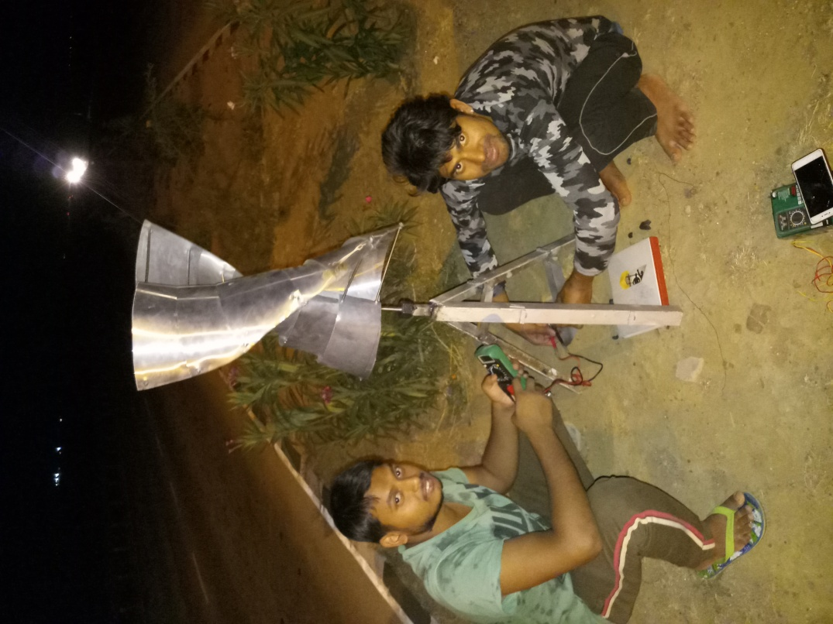

FIGURE 2.6: HIGHWAY WIND TURBINE TESTING

11

**2.4 Conceptual Design (Design Alternatives)**

There are several ways to approach this particular design problem. Inliterature surveys, we discovered different features of wind turbines which were appealing for different reasons. For example, the gear turbines in China were very inexpensive and the modular sections could easily be snapped together to form a bigger system. That particular design did not seem as environmentally friendly as the designs with larger propellers.Other designs include turbines built into highway dividers or on overhead poles as seen in the design by the Arizona State Student Joe (last name not provided) (Joe, 2007). Joe calculated that with cars moving at 70 mph, 9,600 kilowatts of electricity could be produced per year using his design.

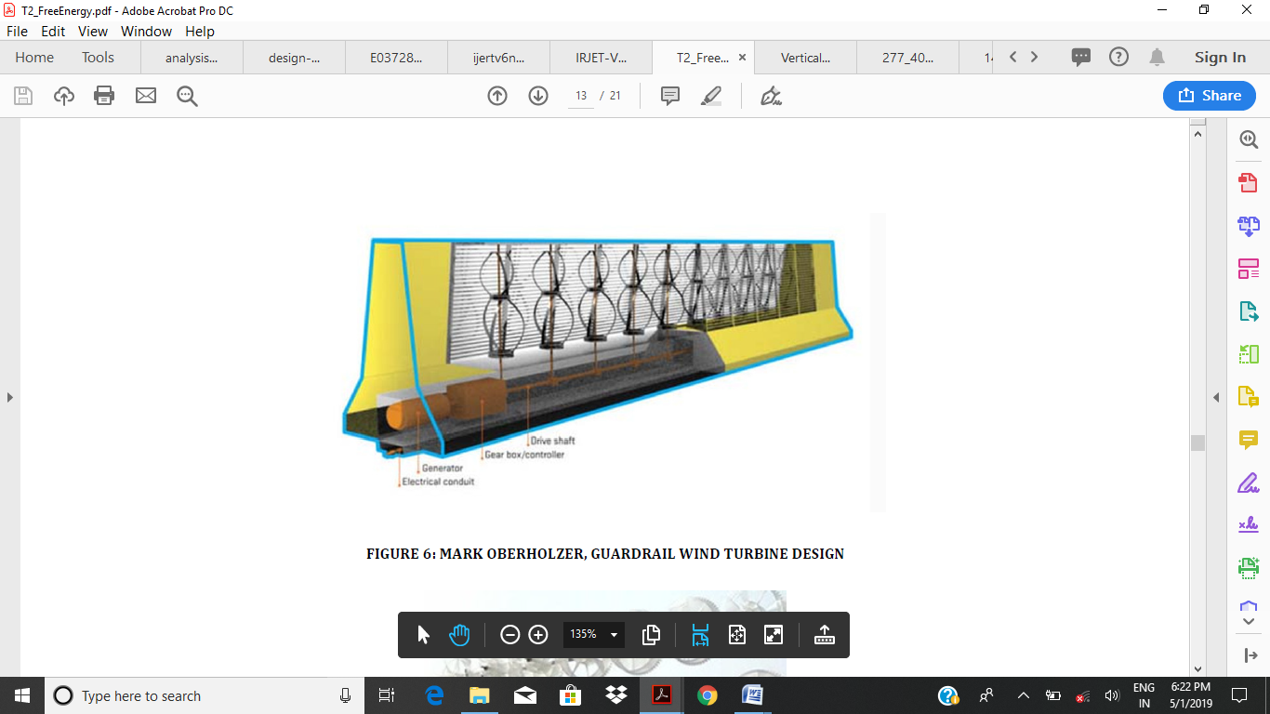

FIGURE 2.7: MARK OBERHOLZER, GUARDRAIL WIND TURBINE DESIGN

12

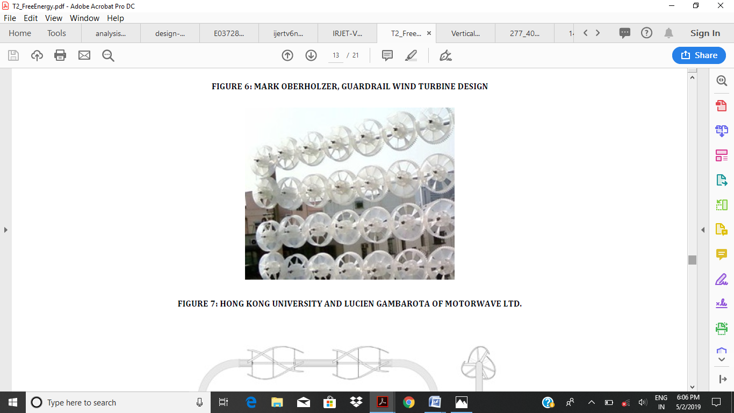

FIGURE 2.8: HONG KONG UNIVERSITY AND LUCIEN GAMBAROTA OF MOTORWAVE LTD.

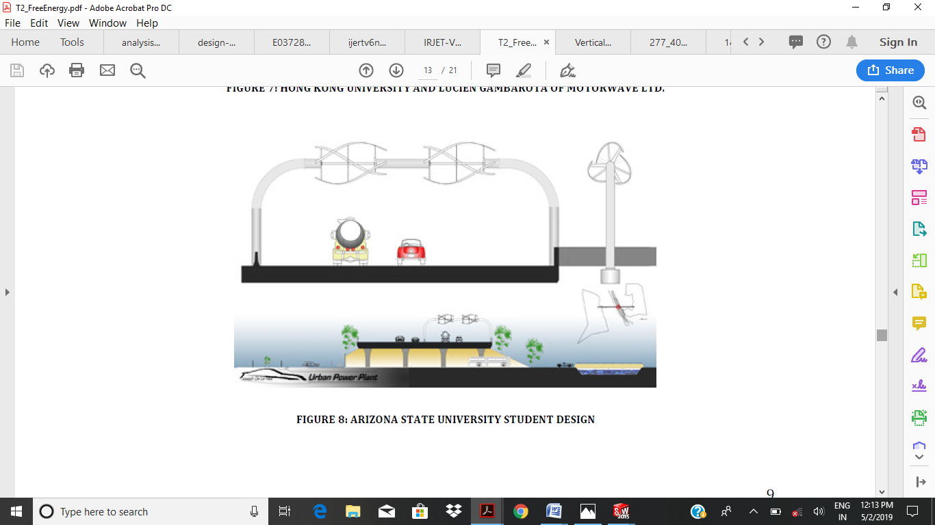

FIGURE 2.9: ARIZONA STATE UNIVERSITY STUDENT DESIGN

13

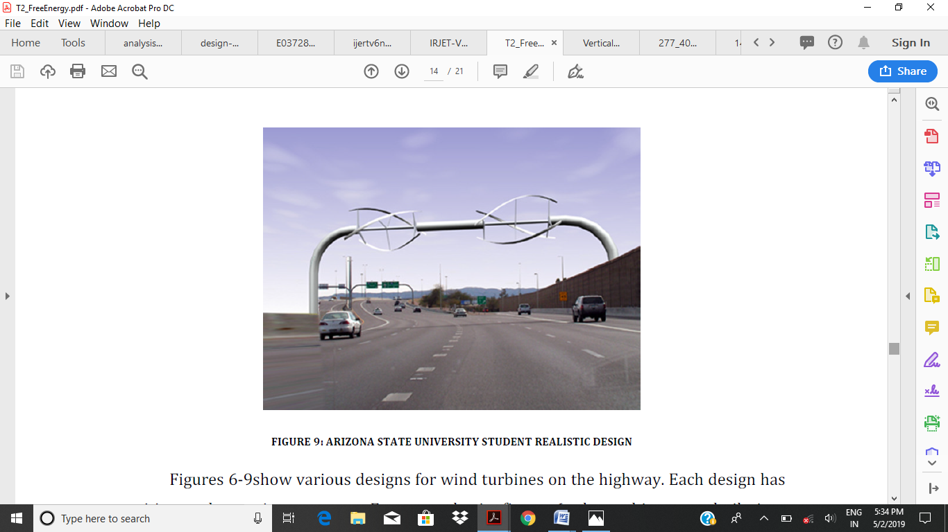

FIGURE 2.10: ARIZONA STATE UNIVERSITY STUDENT REALISTIC DESIGN

Figures 2.7-2.10 show various designs for wind turbines on the highway. Each design has positive and negative aspects. For example, in figure 6, the turbines are built into guardrails. This design is particularly complex because the guardrails must be fitted with vanes in order for the wind produced by vehicles to reach the turbines inside. Figure shows an inexpensive wind turbine design. This design was not selected due to safety considerations. The parts are small and can easily be snapped out of place. Figures 2.6 and 2.7 show wind turbines proposed by an Arizona State University student. This design rejected because it requires the construction of custom support posts.

14

**CHAPTER 3**

**SYSTEM DESIGN**

**3.1 Requirement Constraint Specification**

**3.1.1 General specifications**

Aero leaf wind turbine is new way of producing energy form Vertical-axis method. This new energy source is useful in the modern cities because of it is nice design and free noise. These wind energy generators are. The Aero leaf tree is designed hold two wind Savonius turbine, which are small in size and can produce up to 300 watts.

The positive point of wind energy is that unlike solar energy that only can be used with sunlight only. Wind energy can be useful all the 24 hours all the year. This project is green source of energy and has no effect on the life of earth.

There are no effects on the environment at all. Moreover, it is reduce the CO2 and CO gases that effect the environment in the earth. One of the biggest challenges is the social accept of Aero leaf Wind turbine.

**3.1.2 Constraints and requirements**

One of the most difficultly problem is the lack of necessary equipment needed for the analysis and selection of materials accurately in the university. Also, in the market, I was really difficult to find some of the needed materials.

These problems make the function of this project relying for some parts in design of previous studies mentioned in chapter 2 by doing the reverse engineering.

Getting a sufficient wind, to analyze and test work. It was also the one of the berries that we have encountered, because of the lack of wind in the area at that time, and the lack of experience in aerodynamic science.

Beside the Lack of important resources, the lack of financial support was a major obstacle in our way even though the budget was estimated.

15

Although the existence of moral support from our professors, Lack of sufficient time was a real challenge to show up the work as long as there was only one semester to complete the senior project.

**3.2 Design Methodology**

The methodology applied to this project can be divided into six phases. These phases are information gathering, concept generation, model generation, model analysis and refinement, concept selection, and verification, these phases are shown in figure 3.1.



Figure 3.1: Applied Phases of used Methodology

Prior any appropriate solution can be developed, a thorough investigation has to be conducted in order to find out what solutions have already been proposed (information gathering).

Once these solutions have been analyzed and the team has an understanding of why the respective solutions are not currently being implemented, a solution generation phase is taking place. Here various solutions are presented and evaluated against criteria and constraints (concept generation). Solution concepts are then modeling

The results of the models are then analyzed and the model, as well as solution parameters, may be tweaked (model analysis and refinement).

Once the team has satisfactorily modeled all solution concepts of interest, the concept that performs best analytically, in addition to meeting all criteria and constraints, is selected (concept selection). The analytical model may then be verified experimentally, using a small scale modeling scheme or through a full scale experimental model.

16

The objective of this project is to design a vertical axis wind turbine (VAWT) that could generate power under relatively low wind velocities. To accomplish this goal, the objectives are to:

* Analyze how different geometry of the wind turbines would affect the output power

of the wind turbine.

* Vibrations analysis by testing how the vibrations caused from the rotations of the wind turbines affect the structural integrity of various aspects buildings structures.
* Compare the operation of turbines with respect to the numbers of attached blades.

**To meet the above objectives, the tasks were to:**

* Conduct background research and analysis on wind turbine technology.
* Design initially turbine blade for testing.
* Design tree to hold these turbines.
* Looking for power generator that has good efficiency with low startup speed.
* Create experimental set up.
* Manufacture parts and build model tree.
* Develop future design recommendations.

**3.3 Proposed Design**

Our group is proposing to design a vertical axis wind turbine to utilize the wind produced by moving vehicles to generate electricity. These turbines will be placed along roadways that have high volume of fast moving traffic. The electricity generated will then be the stored in batteries. Since the electricity produced will be direct current (DC) it must be converted to alternating current (AC) before it can be used for lighting the street lamps, sold to the grid or any of the man ways we use electricity today. This means that the DC current must be pasted through an inverter first before it is used Figure 3.2 shows a sample vertical axis wind turbine with part labels however; the turbine we are designing will likely reflect the design in Figure3.3.

17



FIGURE 3.2: LABELED PARTS OF A VERTICAL WIND TURBINE



FIGURE 3.3: CAD MODEL OF HIGHWAY WIND TURBINE

18

There are several advantages and disadvantages to using a vertical wind turbine design. A vertical wind turbine design is selected because vertical turbines are capable of capturing wind in any direction, whereas, horizontal turbines need to be pointed in the direction of the wind. Additionally, heavy parts such as the generator and battery can easily be placed at the base of the turbine.

**3.4 MAJOR COMPONENTS**

3.4.1 Blade

3.4.2 Centre Shaft

3.4.3 Generator

3.4.4 Bearing

**3.4.1 Blades**: While designing the size of blade it is must to know the weight and cost of blades. The ideal wind generator has an infinite number of infinitely thin blades. In the real world, more blades give more torque, but slower speed, and most alternators need fairly good speed to cut in. Blade designs are very fast (and therefore perform very well) and easy to build, but can suffer from a chattering phenomenon while yawing due to imbalanced forces on the blades.

Blade designs are very common and are usually a very good choice, but are harder to build than designs.

**Specification of blade:-**

Material – Aluminium sheet

Thickness -1mm

19

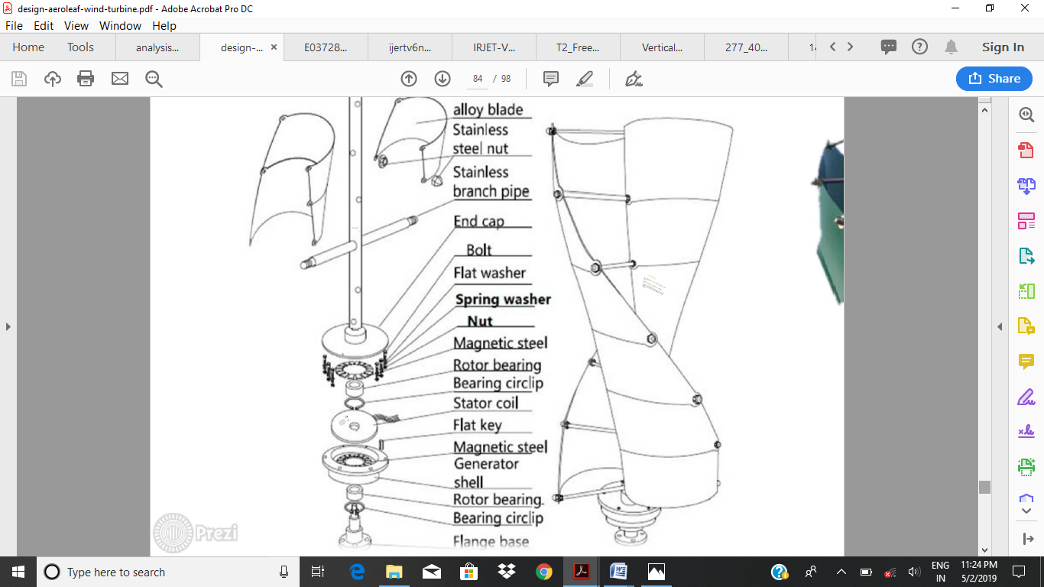

FIGURE 3.4: BLADE DESIGN OF HIGHWAY WIND TURBINE

**3.4.2 Center Shaft-** The shaft of the turbine consists of a single 1000mm length of steel measuring 12mm in diameter shown in figure 3.5. The use of silver steel over a lighter metal such as cast iron was based on the availability of materials. The top and bottom ends mild steel of length 1inch each are respectively are fixed to give strength to the hollow shaft. A solid shaft rotating at 75 rpm is assumed to be made of mild steel. The yield strength of a mild steel shaft material (C50) from design data is 380Mpa . (380/ (2x 2)) The safe load is 300N (Approx 30Kg).The shaft of length 1500mm is subjected to bending and torsion stresses. The diameter of shaft taken is 25 mm is safe after testing both bending and torsion.

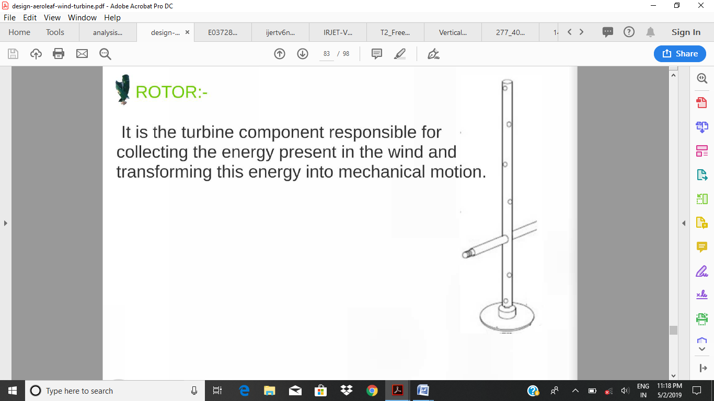

FIGURE 3.5: DRILLED CENTRE SHAFFT

20

**3.4.3 Generator:** For generation of electricity from the designed our vertical axis wind turbine, we chose a dynamo which has the capacity to light a bulb of 12 V. The selected dynamo is shown in Fig 3.6.

 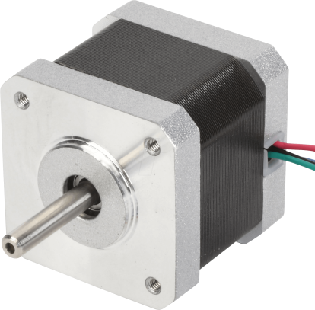

FIGUR3.6: GENERATOR

**3.4.4Bearing:** For the smooth operation of Shaft, bearing mechanism is used. To have very less friction loss, the two ends of shaft are pivoted into the same dimension bearing. The Bearing has diameter of 12mm. Bearings are generally provided for supporting the shaft and smooth operation of shaft. The Fig.3.7 shown the ball bearing used in the turbine.

**Specifications**

6021 SKF Open Deep Groove Ball Bearing

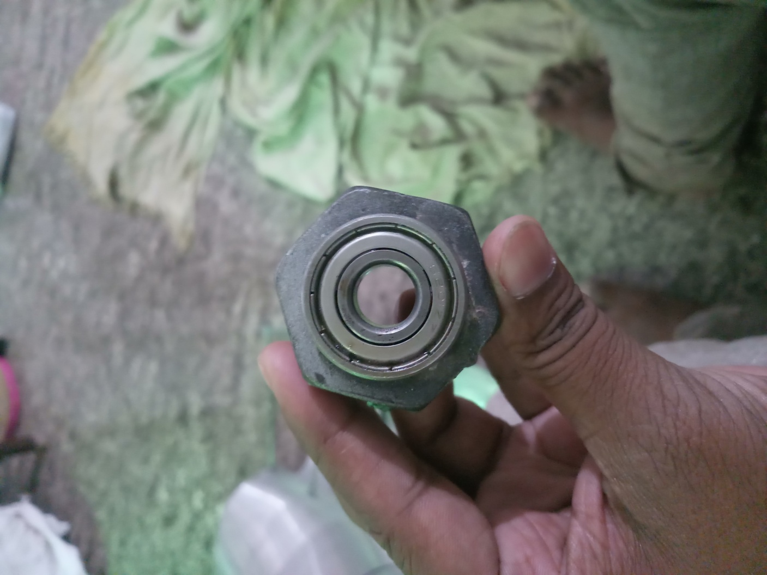

FIGURE 3.7: BEARING OF HIGH WAY WIND TURBINE

21

**3.5 Methodology**

**3.5.1 Vertical Axis Wind Turbine**

The vertical axis wind turbine is used to convert the kinetic energy into mechanical energy. The light weight blade materials (mica sheet) are used for making the vertical axis wind turbine. The height of blade is 60mm and width of blade is 55mm. The whole turbine is assembling with collar and blades which is fitted by nut bolts. To achieve the unidirectional motion of the turbine the blades are bended by 30degree angle curve shape and shaft of the turbine connected to the shaft of generator.

**Turbine Specification**

Height of blade= 0.6 meter

Height of shaft= 1.0 meter

Helix angle= 30degree

Vertical shaft diameter= 12 mm

Overall outer diameter= 0.55 meter

22

**CHAPTER 4**

**4.SYSTEM TESTING AND ANALYSIS**

**4.1 Theoretical wind turbine power calculation**

The following formulas are utilized to design the most efficient turbine.

Power available = 1/2ρAV^3

The power coefficient (CP) is the power extracted divided by the power available.

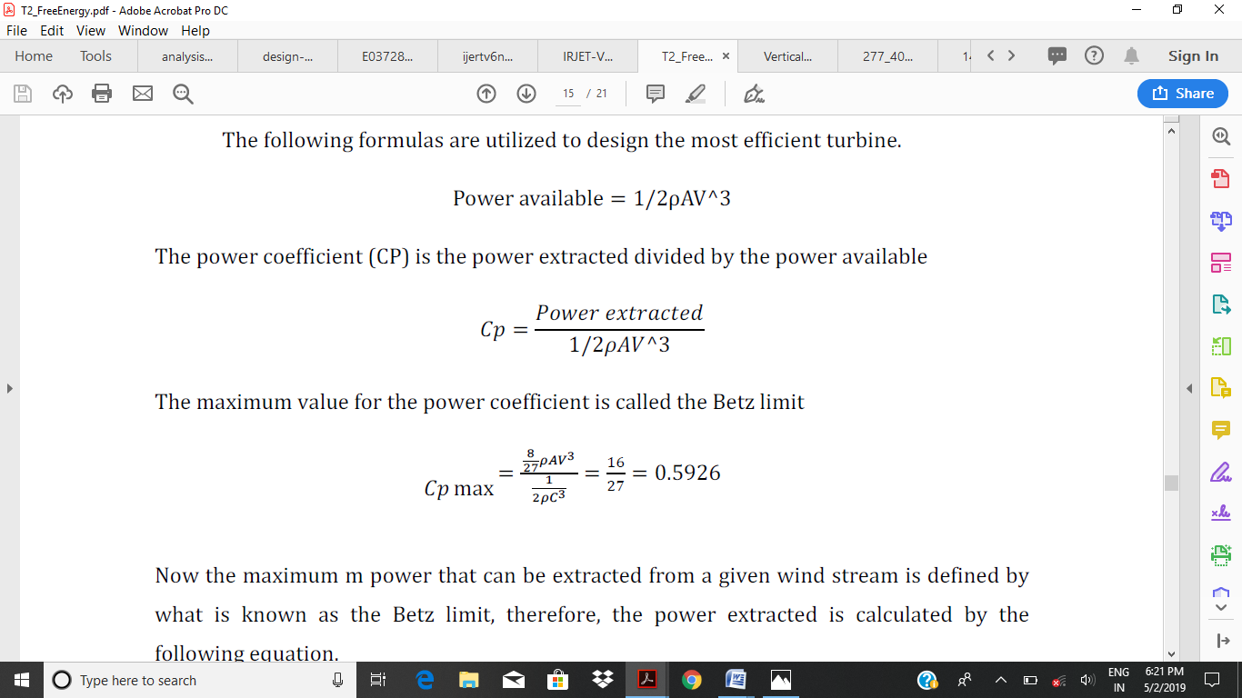

The maximum value for the power coefficient is called the Betz limit.

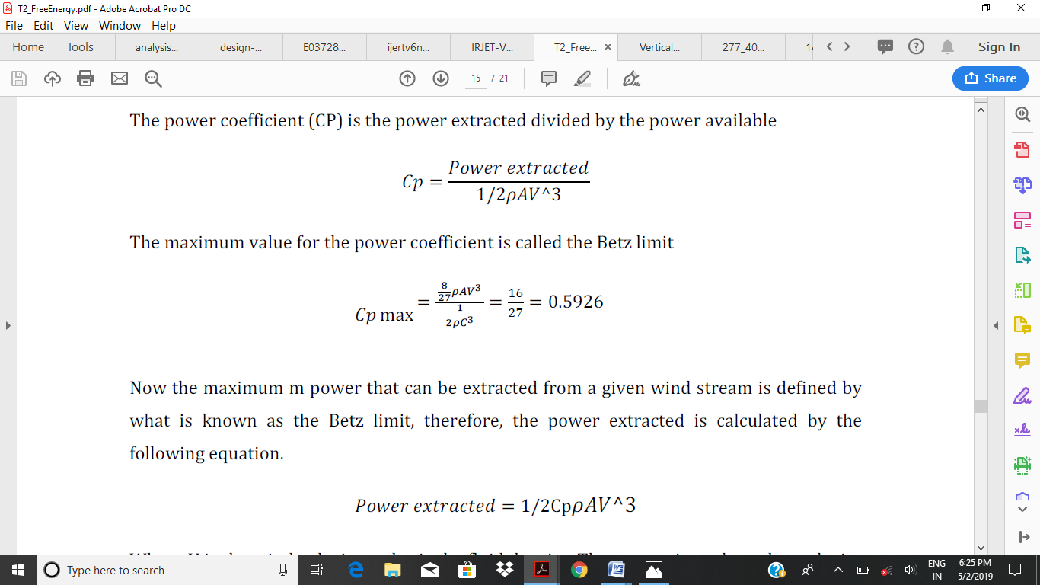

Now the maximum m power that can be extracted from a given wind stream is defined by what is known as the Betz limit, therefore, the power extracted is calculated by the following equation.

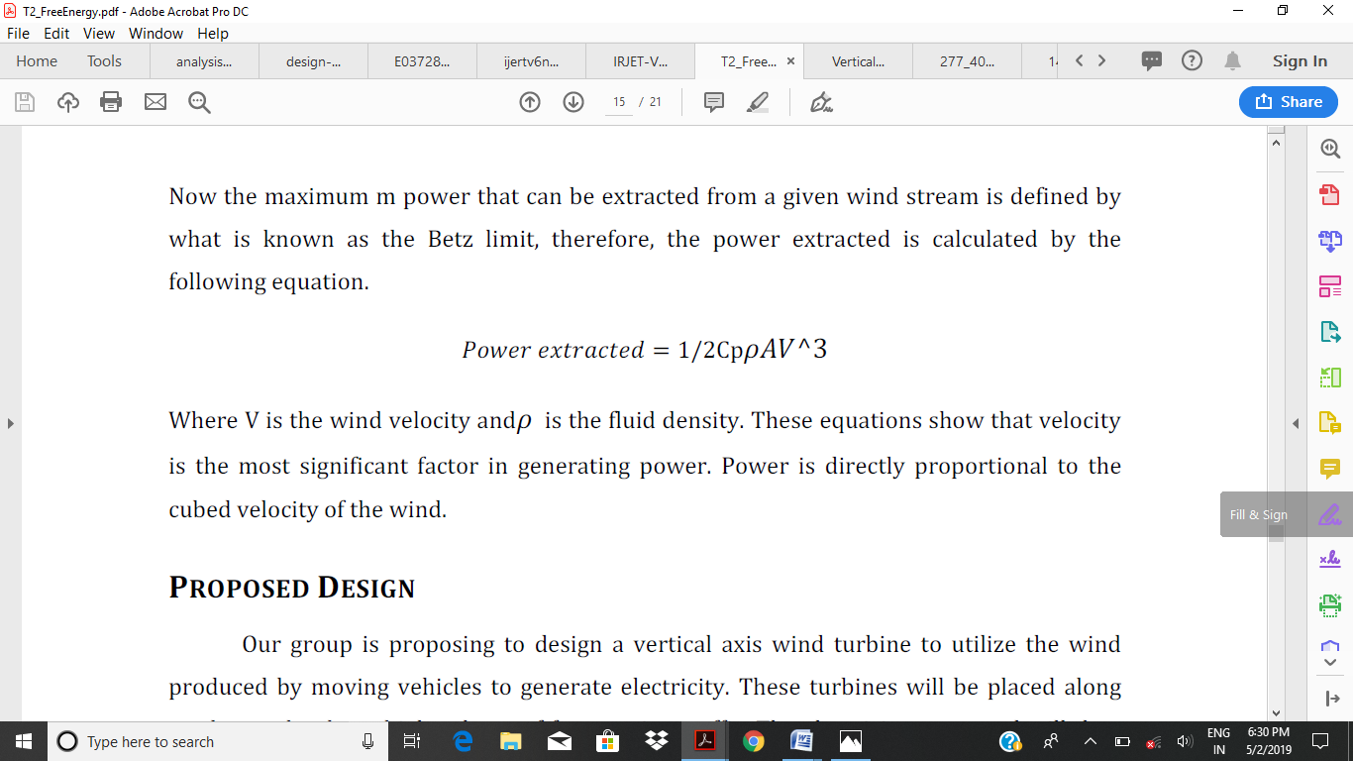

Where V is the wind velocity and Ꝭ is the fluid density. These equations show that velocity is the most significant factor in generating power. Power is directly proportional to the cubed velocity of the wind.

23

**TABLE 4.1:Theoretical Gained Power Calculation**

|  |  |  |  |  |
| --- | --- | --- | --- | --- |
| Density of air=  1.2 | Area=h*w  1.1*.6=.66 | Wind speed | Cp =0.592 | Power watt |
| 1.2 | .66 | 1 | .592 | .23 |
| 1.2 | .66 | 2 | .592 | 1.8 |
| 1.2 | .66 | 3 | .592 | 6.32 |
| 1.2 | .66 | 4 | .592 | 15 |
| 1.2 | .66 | 5 | .592 | 29.3 |

**4.2 Experimental Readings**

After designing the components and structures desired for testing power output for wind turbine designs and the structures desired to be tested, we created the experimental set-ups required to test the prototypes and structures. In order to determine the effectiveness of the products that were manufactured, we performed tests to evaluate them. The test set up was in Half Moon (Hanging Bridge). We also tested the power output of the turbine .

experiments have been conducted; the procedure of calculating the power is counting the voltage & current that feeding the battery. The power gained can be calculated using the

below equation.

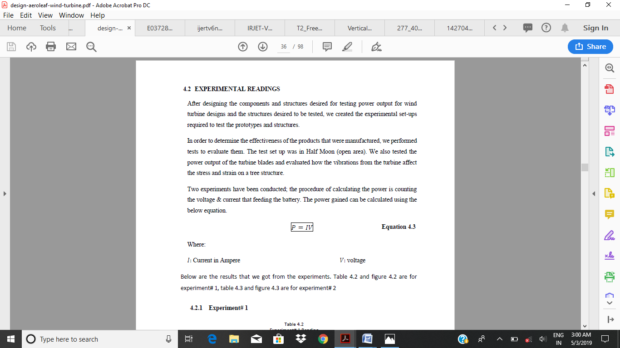

24

**Table 4.2 Experimental Reading**

|  |  |  |  |
| --- | --- | --- | --- |
| **Types of vehicle** | **Votage (by multimeter)**  **volt** | **Current (by multimeter)**  **Ampere** | **Power**  **Watts** |
| **Car** | 6.3 | 2.1 | 13.3 |
| **4-wheel truck** | 9.2 | 2.6 | 23.9 |
| **6-wheel truck** | 9.3 | 2.7 | 25.1 |
| **10-wheel truck** | 10.9 | 2.9 | 31.6 |
|  |  |  |  |

25

CHAPTER 5

**6.**

**PROJECT ANALYSIS**

**5.1 Project management**

Our belief in the professionalism and workmanship at work put us in a position where we work in the concept of project management. Project management is the process and activity of planning, organizing, motivating, and controlling resources, procedures and protocols to achieve our goals.

A project is a temporary endeavor designed to produce a unique product, service or result with a defined beginning and end (usually time-constrained, and often constrained by funding or deliverables), undertaken to meet unique goals and objectives, typically to bring about beneficial change or added value.

Like any other project, the senior student project described in this report needed attention in terms of project management. Achieving minimum goals set by the university (client in project management terminology) regarding the senior projects was a challenge in presence of certain constraints such as time, scope and budget. Furthermore, achieving the best quality was simply not possible in the absence of a proper equipment and the required laboratories and tolls that needed for such projects.

On the contrary, to the above-mentioned importance of applying project management strategy in the discussed project, it is also evident that the project had a limited scope and resources to be managed. Therefore, a simple and traditional strategy, as outlined in the following block diagram, was adopted to make sure the project is successfully completed within the specified time and budget frames.

**5.1.1 COST ANALYSIS**

We do not have a sponsor for this project therefore the costs is divided among group members. Average cost of some turbine parts are listed in Table 5.1 shows average costs of several of the major components in a vertical wind turbine. To reduce costs, some of the components will be

26

manufactured such as the wind turbine blades.

Table 5.1: cost analysis of HWT

|  |  |  |
| --- | --- | --- |
| **Quantity element** | **element** | **Price Rs** |
| **1m2** | Aluminium sheet | 3000 |
| **1** | Dynamo | 1800 |
| **2** | Bearing | 400 |
| **1** | Shaft | 2114 |
| **1** | Angle rod | 1120 |
|  | **Total cost** | **8434** |

**5.1.1 Contribution of Team Members**

Contribution of the team members of this project was proactive, the team work was going

smoothly over the semester achieving the milestone one by one. All the group members

were participating in all of this project steps,

This project steps are:

* Planning Research and Analysis
* Designing and Manufacturing
* Bi-weekly reports
* Weekly meetings
* Final report writing
* Mid and Final presentation
* Final demonstration

**5.2 Life-long learning**

This experience that the team have went through is very valuable in term of engineering sense, skills, and knowledge. Guidance from PMU instructor and advisors were very valuable and

27

help achieving the main goal of this course. Teamwork and leadership were applied through this experience which add good management skills to the team members. Fabrication and manufacturing was not easy where we had to change the manufacturing

workshop several time and that is due to the inefficient tools that they are using, choosing better workshop with high stander will cost more money .We were facing a lot of difficulties getting the required equipment and materials with the right dimensions. Testing, analysis, and evaluating our result was difficult specially when come to calculation the experimental results. The assigned time to finish such senior project was not enough, which add more pressure to the team members taking in consideration the others courses the team members are taking in the same semester.

**5.3 Impact of engineering solution**

**5.3.1 Renewable Energy**

Energy resources are getting more difficult to get. With the increasing of the population, and high demand of the power, and taking in consideration the current situation of the oil prices and it reliability. Saudi Arabia has to start as soon as possible implementing the use of renewable energy. Wind energy can be very useful for this purpose. This project and research as any other similar studies are convincing that wind energy can help a lot the country supplying power with these renewable energy which can be costly at the beginning, but it will be the most reliability solution that can apply the concept of sustainability.

**5.3.2 Economy**

As the largest economy by far in the Middle East, Saudi Arabia is also the largest potential RE market in the region. The country developed a massive renewable energy program that aimed to install 54 GW by 2032; this program, however, has been delayed and likely will not be implemented as originally announced.

Nevertheless, Saudi Aramco and Saudi Electricity Company are both going ahead with their own initiatives and joint plans to develop renewable energy in Saudi Arabia in the short and medium term. Expect significant growth in the coming years for both solar and wind, as the Kingdom strives for a sustainable energy mix to preserve a large share of extracted oil for future export.

28

Within GCC, Saudi Arabia is the most promising market for wind. With a surface area of 2.25 million km² and a GDP of USD 730B, Saudi Arabia is the largest country and economy in the GCC.

Saudi Arabia accounts for half of GCC’s power demand (273 TWh in 2012) and will be the region’s primary wind market in the short term (100 out of the region’s 200 MW installed capacity by 2015). As a result of the immense power demand, an additional 47 GW and approximately 29 GW of replacement capacity are needed by 2020.

Saudi Arabia provides various suitable sites for large-scale onshore wind generation. The first criterion for site suitability is a minimum wind speed of around 3.7 m/s at a height of 10 m in order for wind generation to be competitive with the LCOE of oil-fired electricity generation. Secondly, suitable wind power sites must also have adequate access to the electricity network.

The majority of sites fulfilling these requirements are situated along the two coastlines, for example, Yanbu in the West and Juaymah and Dammam/Al Khobar/Dhahran in the East (Figure 5.1). With existing wind measurements limited to location of meteorological stations only, additional attractive sites can be expected in unchartered regions.

29

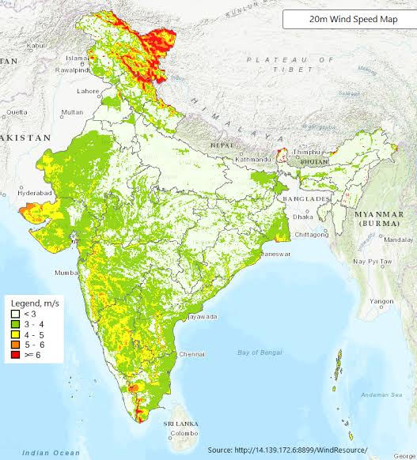

Figure 5.1: Average Wind Speed Reading in India

**5.4 Contemporary issue adressed**

In May 2012, the Saudi government announced one of the world’s most ambitious renewable

energy programs. Government body K.A.CARE plans for the installation of 9 GW of wind power capacity by 2032 and aims to release the first round of tenders in large renewable power generation projects in the next couple of months. By 2017, a cumulated capacity of up to 1.8 GW is expected to be installed.

The country’s ambition to strongly develop wind alongside solar power is serious. Countrywide assessments for suitable wind sites are currently being conducted on behalf of K.A.CARE and national oil and gas company Saudi Arabia.

**5.5 Advantages:-**

VAWTs offer a number of advantages over traditional [horizontal-axis wind turbines](https://en.wikipedia.org/wiki/Horizontal-axis_wind_turbine) (HAWTs):

30

* Being omni-directional, some forms do not need to track the wind. This means they don't require a complex mechanism and motors to yaw the rotor and pitch the blades.
* VAWTs generally function better than HAWTs in turbulent and gusty winds. HAWTs cannot efficiently harvest such winds, which also cause accelerated fatigue. the gearbox of a VAWT takes much less fatigue than that of a HAWT.
* In VAWTs, gearbox replacement and maintenance are simpler and more efficient, as the gearbox is accessible at ground level, so that that no cranes or other large equipment are needed on-site. This reduces costs and impact on the environment. Motor and gearbox failures generally are significant considerations in the operation and maintenance of HAWTs both on and offshore.
* Some designs of VAWTs in suitable situations can use [screw pile](https://en.wikipedia.org/wiki/Screw_pile) foundations, which hugely reduces the road transport of concrete and the carbon cost of installation. Screw piles can be fully recycled at the end of their life.
* Wings of the Darrieus type have a constant chord and so are easier to manufacture than the blades of a HAWT, which have a much more complex shape and structure.
* VAWTs can be grouped more closely in wind farms, increasing the generated power per unit of land area.
* VAWTs can be installed on HAWT wind farm below the existing HAWTs; this can supplement the power output of the existing farm. Research at [Caltech](https://en.wikipedia.org/wiki/California_Institute_of_Technology) has also shown that a carefully designed wind farm using VAWTs can have an output power ten times that of a HAWT wind farm of the same size.

**5.6 Disadvantages:-**

* One of the major outstanding challenges facing vertical axis wind turbine technology is dynamic stall of the blades as the angle of attack varies rapidly.
* The blades of a VAWT are fatigue-prone due to the wide variation in applied forces

during each rotation. This can be overcome by the use of modern composite

31

materials and improvements in design - including the use of aerodynamic wing tips that cause the spreader wing connections to have a static load. The vertically oriented blades can twist and bend during each turn, causing them to break apart.

* VAWTs have proven less reliable than [HAWTs](https://en.wikipedia.org/wiki/Wind_turbine#Horizontal_axis), although modern designs of VAWTs have overcome many of the issues associated with early designs.

**5.7 Applications:-**

The Wind spire, a small VAWT intended for individual (home or office) use was developed in the early 2000s by US company Mariah Power. The company reported that several units had been installed across the US by June 2008.

Arbor wind, an Ann-Arbor (Michigan, US) based company, produces a patented small VAWT which has been installed at several US locations as of 2013.

In 2011, [Sandia National Laboratories](https://en.wikipedia.org/wiki/Sandia_National_Laboratories) wind-energy researchers began a five-year study of applying VAWT design technology to offshore wind farms. The researchers stated: "The economics of offshore wind power are different from land-based turbines, due to installation and operational challenges. VAWTs offer three big advantages that could reduce the cost of wind energy: a lower turbine center of gravity; reduced machine complexity; and better scalability to very large sizes. A lower center of gravity means improved stability afloat and lower gravitational fatigue loads. Additionally, the drive train on a VAWT is at or near the surface, potentially making maintenance easier and less time-consuming. Fewer parts, lower fatigue loads and simpler maintenance all lead to reduced maintenance costs."

A 24-unit VAWT demonstration plot was installed in southern California in the early 2010s by [Caltech](https://en.wikipedia.org/wiki/California_Institute_of_Technology) aeronautical professor [John Dabiri](https://en.wikipedia.org/wiki/John_Dabiri). His design was incorporated in a 10-unit generating farm installed in 2013 in the Alaskan village of Igiugig.

[Dulas, Anglesey](https://en.wikipedia.org/wiki/Dulas,_Anglesey) received permission in March 2014 to install a prototype VAWT on the breakwater at Port Talbot waterside. The turbine is a new design, supplied by Wales-based C-FEC (Swansea), and will be operated for a two-year trial. This VAWT incorporates a wind

shield which blocks the wind from the advancing blades, and thus requires a wind-direction

32

sensor and a positioning mechanism, as opposed to the "egg-beater" types of VAWTs discussed above.

4 Navitas (Black pool) have been operating two prototype VAWTs since June 2013, powered by a Siemens Power Train, they are due to enter the market in January 2015, with a free technology share to interested parties. 4 Navitas are now in the process of scaling their prototype to 1 MW, (working with PERA Technology) and then floating the turbine on an offshore pontoon. This will reduce the cost of offshore wind energy.

The Dyna sphere, is [Michael Reynolds](https://en.wikipedia.org/wiki/Michael_Reynolds_(architect))' (known for his [Earth ship](https://en.wikipedia.org/wiki/Earthship) house designs) 4th generation vertical axis windmill. These windmills have two 1.5 KW generators and can produce electricity at very low speeds.

33

**CHAPTER 6**

**7.**

**2. CONCLUSIONS AND FUTURE SCOPE**

**6.1 Conclusion**

From our research we were able to come up with many important conclusions and suggestions which will profit the future advancement of individual vertical pivot wind turbines. We could outline a VAWT framework that enhanced power yield when contrasted with the past projects. From our results we were able to recommend new design aspects to improve the system and efficiency.

Inefficient wind speed was the huge impact getting the required power output, minimum speed of 12 m/s is required to have acceptable output power taking in consideration 31~35% of efficiency between theoretical and experimental results.

Even though we were able to make this design of Vertical Axis Wind Turbine but there is a never ending process to always improve upon inventions and new designs. Wind turbines are a start for society to lessen the damage done to the earth by not using energy sources that produces pollution. Hopefully the project could propel research and testing on VAWT frameworks and give knowledge for different gatherings to finish additionally testing and enhance productivity and execution of vertical pivot wind turbines.

**6.2 Future Scope**

Using the data received we made recommendations for future studies regarding the potential of commercial tree wind turbines. These recommendations will hopefully aid in the development of a technology that would allow green energy to reduce energy costs in the average household and better the environment. Future tests could help determine the feasibility of houses, neighborhoods, or cities powered by wind turbines and being able to run off of renewable energy.

The turbine performance testing and results from the research in this venture demonstrated that

the split Savonius is the best plan that has been tried to this point at WPI. The reason is because

of the expansive surface range of the split Savonius which empowers it to catch most maximum

34

amounts of wind. We trust that further research ought to be finished with different Savonius plans in view of this reality. The Savonius turbine outlines are basic and modest to make, and are additionally not incredibly influenced by turbulence in the wind.

Another suggestion to improve the Savonius design in our opinion would be to create a more aerodynamic backing to the Savonius cusp. This design would reduce the energy it requires to

spin with the wind. this will allow the Savonius to rotate into the wind more efficiently, thus increasing the rate of revolution. While we do not expect this to make a significant difference, our testing demonstrates that even small differences in wind speeds lead to significantly improved power output.

To gain the best power gain in the concept of green energy, we strongly recommend having some solar panels attached to the tree. These panels will add more power and they are easy to install and connected to the electrical components that are already added to the system.

35

**References:-**

[1] Mr. Mukesh Kumar Sharma. Assesment of wind energy potential from highways. In International Journal of Engineering Research and Technology, volume 1. ESRSA Publications, 2012.

[2] Ali Zarkesh and Mohammad Heidari. Developing a new application for wind generators in highways. In Computational Intelligence, Communication Systems and Networks (CICSyN), 2013 Fifth International Conference on, pages 279–282. IEEE, 2013.

[3] Batista, N. C Batista, N. C., Melício, R., Matias, J. C. O., & Catalão, J. P. S. New blade profile for Darrieus wind turbines capable to self-start. Renewable Power Generation (RPG 2011), IET Conference on. IET, 2011

[4] R Sathyanarayanan, S Muthamizh, C Giriramprasath, and KT Gopinath. Highway windmill. In Communication Software and Networks (ICCSN), 2011 IEEE 3rd International Conference on, pages 343– 347. IEEE, 2011.

[5] Scheurich, Frank, and Richard E. Brown. Modelling the aerodynamics of vertical‐axis wind turbines in unsteady wind conditions. Wind Energy 16.1 (2013): 91-107.

[6] Barazarte, Ronald Y., G. G. Gonzalez, and Edilberto Hall. Comparison of Electrical Generators used for Wind Power Generation. Latin America Transactions, IEEE (Revista IEEE America Latina) 9.7 (2011): 1040-1044.

[7] Chen, Yicheng, Pragasen Pillay, and Azeem Khan. PM wind generator topologies. Industry Applications, IEEE Transactions on 41.6 (2005): 1619-1626.

[8] R. Alejandro, L. Alvaro, G. Vazquez, D. Aguilar and G. Azevedo, Modeling of a Variable Wind Speed Turbine with a Permanent Magnet Synchronous Generator. IEEE Inter. Symposium on Industrial Electronics (ISIE), Seoul, Korea July 5-8, 2009.

[9] M.K. Sharma ”The study of wind energy potential from highway”. In International Journal of Engineering Research and Technology, 2012.

[10] “J Berrocal, Brian Dolan, M Tangredi” “Design of Vertical Axis Wind Turbine to Power Led Street Lights” 2013.

[11] S.Selvam, Edison Prabhu .K, Bharath Kumar M.R, & Andrew Mathew Dominic “Solar and Wind Hybrid power generation system for Street lights at Highways” International Journal of Science, Engineering and Technology Research (IJSETR), Volume 3, Issue 3, March 2014.

36

[12] Mithun K K and Ashok S “Wind Turbine for Highway Wind Power Generation” IJEEE, Volume 07, Issue 01, Jan- June 2015.

[13] Dhiraj Varma and Ajitabh Pateriya “VAWT and Solar Panel Combine System Based Generation of Electricity through Highway" IJRISE, Vol.3, 2017. pp: 137-140.

[14] Scheurich, Frank, and Richard E. Brown “Modelling the aerodynamics of vertical axis wind turbines in steady wind conditions" Wind Energy 16.1 (2013): 91-107.

[15] Shweta Singh, Sarita Singh and Priyank Srivastava “Vertical Axis Wind Turbine for Generation of Electricity through Highway Windmill” S-JPSET: Vol. 7, Issue 2, ISSN: 2229-7111.

[16] Krishnaprasanth.B , Akshaya.P.R , Mr.Manivannan.L, Ms.Dhivya.N “A New Fangled Highway Wind Power Generation” International Journal for Research in Applied Science & Engineering Technology (IJRASET) Volume 4 Issue I, January 2016.

37